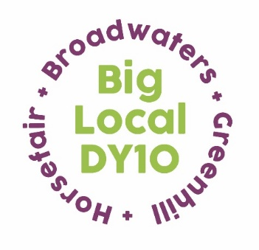
Partnership Meeting Agenda
15th February 2023
Springfield Park Cafe
7:00 pm – 8.30 pm

- Present and Apologies

Brenda, Adrian, Robert, Vander, Jayne, Dot, Margaret, Anna.
Apologies from Lindsay, Jo and Dawn.

- Agreement on the notes from the January meeting and Matters Arising
Charity Update – CIO
Jayne met with Kathy on Zoom and we will now be continuing to move forward and look to arrange a bank account.
St George’s Paddling Pool
There was lengthy discussion with a variety of opinions expressed. Discussion around a possible letter to the council to be deferred until after elections.
- LTO – Finance Update
Robert provided an informative financial update, running through payments made up until 15th February and pending payments. A payment made to St Ambrose Parish Centre was queried. Robert explained that this was for room hire, which has since been cancelled. A refund cheque has been received and will show on the next set of figures.
- Away Day
Margaret ran through the items on the draft agenda she had produced. Robert will bring along the latest figures for reference. Anna will reproduce parts of the plan to bring along on the day. The menu from Bellmans Cross will be distributed to the partnership in advance and preferences sent to Anna, who will bring our order list in the day. Clare Andrews from Local Trust is keen to come along.
- Homestart – End of Year Grant Report
Thank you to Belinda for providing a very positive and thorough annual grant report from Homestart Wyre Forest.
- Easter Shopping Vouchers

Anna has arranged for a supply of Aldi shopping vouchers, through Belinda at Homestart (who have been reimbursed). The Salvation Army and St Ambrose will both receive 15 each to distribute to elderly and/or vulnerable individuals. Anna will also arrange for Dot and Robert to receive a supply of 15 vouchers each to distribute.

- Grants
We have received a grant application from the Wyre Forest Foodbank requesting £2000. This was proposed by Vander and seconded by Adrian. It was agreed by the partnership there is a definite need for this. Anna to inform Sam (referrer), raise the appropriate cover sheet and forward to Robert for payment.
Vander expressed a possible conflict of interest as she is currently a Foodbank referrer.
The partnership were also in agreement that the foodbank on Blackwell Street should be invited to submit a grant application. Adrian and Dot – proposed and seconded.

- Climate Change Update

Anna has received online support from the Centre for Sustainable Energy (CSE) to assist with a series of useful information posts around climate change and cost of living on the Big Local Facebook page. This will come out of our free days support around climate change. Posts will focus on a range of topics such as energy saving advice, keeping warm and what funding/grants are available. A potential competition to round this off was suggested, with related prizes such as a slow cooker, blankets and draught proofing equipment. Budget to be discussed. Energy awareness training sessions for Homestart volunteers are also being investigated.

- Breakfast Meeting?

Brenda and Anna to agree a date in May for a Breakfast meeting.

- Docking Stations
There are spare docking stations available at the Big Print office. There are 10-12 lightweight sleeping bags also available. There was discussion around who may find these useful. Dot indicated that she would have 5 to give to a local family and a homeless individual.
Anna now has a new office space in the Big Print board room. We are paying rental for this until the end of June. Homestart have offered a hot desk space and a meeting space, free of charge.
- AOB
Homestart Contract
This will be ending in June 2023 but we are proposing to extend this due to the dire need. This will total £62k across two years.
Wyre Forest CAB
Further funding – to be discussed at the Away Day.
Margaret
There is support around fundraising and income available through Big Local. Margaret can get in touch with Helen Reilly to find out more for us.
Clare can run through the ‘Closing out and moving on’ guide when she attends our away day.
Dot
Dot indicated possible funding through Echo – Lesaffre. Details were passed to Anna.
Next Meeting

Saturday 25th March (condensed meeting as part of Away Day).

