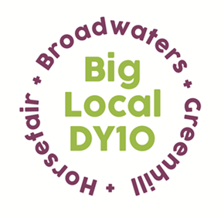
Partnership Meeting
Notes

19th January 2022,
Via Zoom due to current Covid situation
7:00 – 8:30pm
Present:, Helen, Brenda, Jayne, Robert, Dawn, Stacey, Jo, Megan, Sarah, Rachel Symons (WFDC)
Apologies: Adrian, Mattie
The meeting began with a presentation from Rachel Symon, a newly appointed Community Builder with WFDC. She talked about ABCD – Asset Based Community Development and how WFDC are addressing the issues around community engagement after the pandemic. Funding for four posts for 18 months has been awarded by Public Health England via Worcester County Council. These Connectors will work locally in four Wards, Broadwaters (covering Horsefair and Sion Hill) being one of these. Obviously, this is an opportunity for collaborative working with Big Local Dy10. The work they are planning to do mirrors much of what Big Local does or has done in recent years. In the Q & A session that followed we talked about issues such as fly tipping, litter picks and skip days.
Due to time constraints, the following matters were bumped to next meeting:
- Notes from the last meeting and Matters rising from notes:

- Conflicts of interest: None.

- LTO- St George’s finance update: Robert gave a verbal update having circulated the figures to Partners in advance of the meeting.

- The Key Priorities 2022 – 2025. An overview of the Plan was displayed. The KPs had been decided at the Away Day and subsequent Partnership Meetings. Robert confirmed that we had, at this point in time, some £297,000 left but obviously there was a couple of months to go until the new Plan kicked in, so there may be some more spending to take off that figure. The funds available would only allow for a Worker for one year, and we only had sufficient to fund Home Start for one year. It was agreed that in year three activity and spending would decrease as we wound up. A £10,000 award was agreed to the new Legacy Organisation to allow it to start operating and bring in new finds e.g. Lottery Awards for All grant. Sarah expressed disappointment that Climate Change had been included as a Key Priority as ‘everyone was doing it’. However, all our consultations had been around this KP. It was agreed that we could add ‘Improving the Locality’ to the ‘Climate Change’ Key priority.

Since the meeting the spending allocations have been revisited and are now:
As follows:
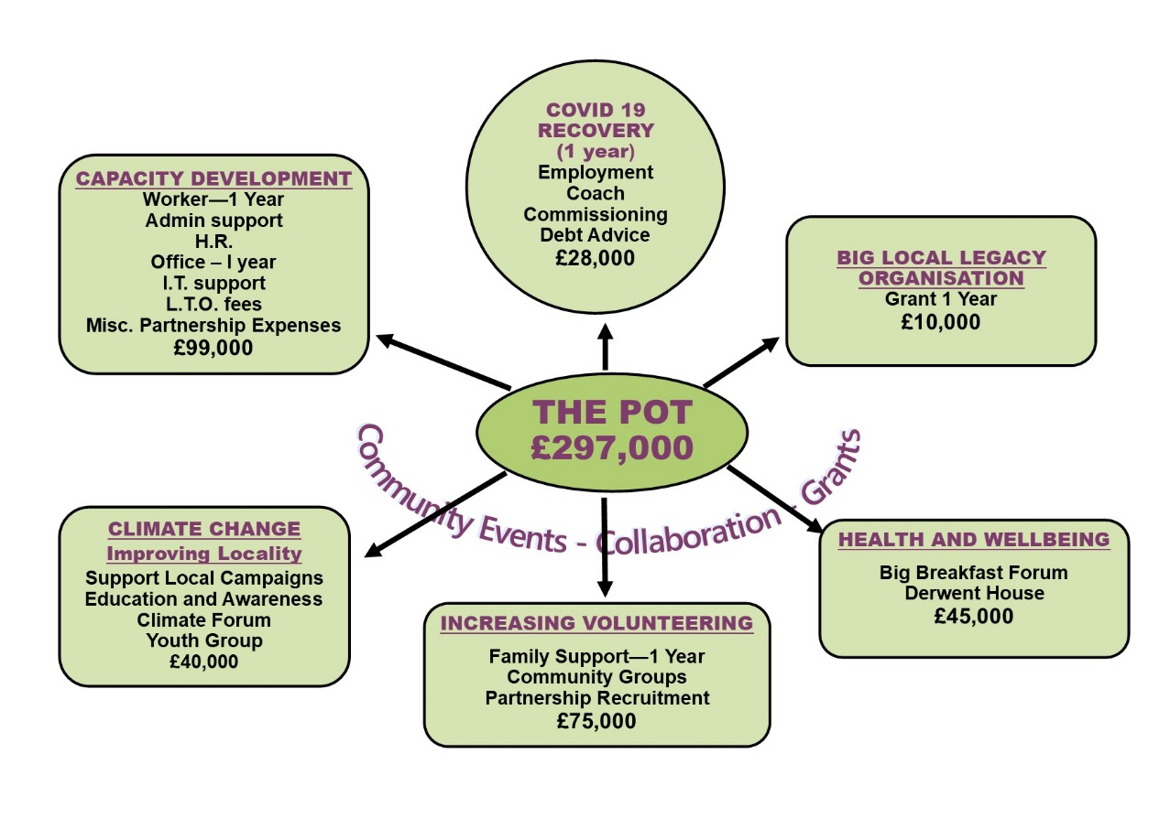

- A.O.B

Stacey gave an update. She has been networking with lots of organisations, however most of them have their own referral systems for job seekers. She is going to do a promo campaign. She has the first few clients now and each has a specific plan to follow. Stacey said it was difficult to find free functional skills training.

Helen announced that she would be resigning as a Big Local Rep in May after 9 years. She said it had been a pleasure being our Rep. Brenda said we would obviously be seeing Helen again before then to express our grateful thanks.

