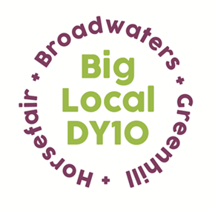
Partnership Meeting
Notes

20th October 2021,
7:00 – 8:30pm
Present:, Mattie, Helen (via Zoom), Adrian, Jayne, Brenda, Robert, Stacey, Jon. Apologies: Dawn, Sarah
- Notes from the last meeting: Notes were read and their acceptance proposed by Adrian and seconded by Mattie, agreed by all.
- Matters rising from notes:
Christmas Packs update. Packs would be ready for schools in 2nd week of December.
- Conflicts of interest: None.
- LTO- St George’s finance update: As financial matters were addressed at the recent Away Day there was nothing to add except that Local Trust had increased their latest payment to £30,000 which Robert had split pro-rata over the categories.
- The New Plan – Key Priorities. At the Away Day 4 Key Priorities (in addition to Capacity Development) were identified and the Partnership spent time adding their ideas under each of the KPs.
Health and Wellbeing: Community events, mental health, fitness classes, tackling loneliness, family support, family cooking sessions were all discussed as major areas we need to address under this KP.
Climate Change: Air quality especially around schools should be tackled maybe promoting a clean air zone. Revisit having a conference around green issues for Primary schools. Going plastic-free and promoting climate friendly options were seen as important. Wildlife gardening and attracting a young mentor such as Chris Packham’s daughter was put forward.
Inclusion, Diversity and Engagement: Start with the Partnership, need to recruit more and varied partners and attract volunteers from our diverse local population. Work with the youth maybe on an on-line forum. Mattie is involved in a ‘Spaces’ forum. More ideas available on Workspace.
Financial Resilience: On-line sessions. A course for care-leavers called Money House. Approach CAB and banks to see what help available that we can promote or buy-in. Use the Cook Book to promote healthy cost-effective eating with videos of recipes to follow.
- Mattie’s Report. Recent sessions of the Leadership Training course had focused on recruitment. As a reflection of personal growth, Mattie had decided to explore moving from Transport Planning to H.R. and was learning to use open and closed questions.
- A.O.B.
Adrian told the Partners that Horsefair and Proud, on behalf of the Horsefair Community, had been awarded the first Charles Talbot Award by the Civic Society.
Helen highlighted how the increase in cost of living, especially food bills was affecting communities.

