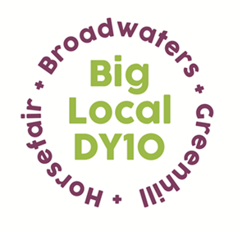
Partnership Meeting
Notes

17th February 2021,
Online Zoom Meeting
8:30 – 9:00pm

- Present: Beth, Brenda, Jayne, Sarah, Robert, Stuart, Dawn, Helen, Adrian, Mattie
Apologies: Vander

- Notes from the last meeting: read and approved. Proposed by Sarah, seconded by Jayne.

- Conflicts of interest: HBG+ budget proposal – Dawn and Mattie as directors

- LTO – St George’s finance update – Partners were asked to look at spend reports that had been circulated. The balance is currently £24,000. Once it reaches £20,000 a claim can be put in to Local Trust.

- Community recovery plan update – The bid to Local Trust for £50,000.00 of additional funding based on the Covid recovery plan has been successful. We will receive the funding in two tranches, the first one should come through in the next few weeks. There will be a discussion in next month’s meeting as to what projects we may support with this funding.

- Family Packs update – Just under 300 activity packs are being sent out fortnightly to local families and those living alone. Additional numbers have been agreed with organisations to adjust to the need in our area. The second batch will be delivered next week.

- HBG+ budget proposal – A budget proposal was circulated. Partners decided that this needs to be looked at further before approval. this will be covered again. A finance meeting is needed for Directors of HBG Plus to discuss this in more detail.

- A.O.B
Grants – Three grant applications were submitted this month, and all were successful. These are:

- St Mary’s Primary school - £500.00 funding for St Mary’s to purchase items to promote the use of their mobile library and engage with families in the area who are not currently attending school.
- St Mary’s Nursery – £2,000.00 towards resurfacing the nursery playground, using a range of textures to create a sensory play area to support local children’s development. The funding will focus on the sensory element of the development.
- Michelle Kimani - £240.00 funding for a perspex protective screen and stand for local sewing shop ‘In Stitches’ to ensure that the store is COVID-19 secure for customers.

Home-Start used part of their family group funds for a movie magic event over half term - families had a popcorn maker delivered, as well as hot chocolate, snacks, and a blanket to watch a film with their children. The blankets were knitted by St George’s ‘knit and knatter’ group, as part of a grant through Big Local DY10, to produce knitted articles for local families.

Mattie asked that the conflict-of-interest policy is recirculated with Partners incase conflicts have changed. They also asked for a calendar for 2021’s Partnership meetings. Beth will email these out to Partners.

The next Partnership meeting will be Wednesday 17th March at 7pm.

