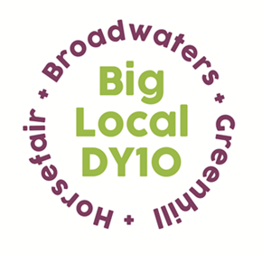
Partnership Meeting
Notes

26th August 2020,
Online Zoom Meeting
8:00pm – 9:10pm

- Present: Beth, Mattie, Brenda, Jayne, Adrian, Laura, Helen, Robert, Vander, Sue Local Trust
Apologies: Stuart
Sue Ansarie from Local Trust attended the first part of the meeting to encourage Partners to fill in the annual Partnership Survey.

- Notes from the last meeting: read and approved

- Conflicts of interest: Personal Development request from a Partner in A.O.B

- LTO – St George’s finance update – Partners were asked to look at spend reports that had been circulated. The fourth pot of money from Local Trust has cleared and Robert has put the funds in line with the original budget heads. He explained that a variation may need to be carried out for health and wellbeing. Cllr Mary Rayner’s donation of £500 towards summer activities has cleared. Robert mentioned that a cheque to Rebecca Baylie for the ‘cakes for care homes’ project had not cleared yet. Beth to chase this up.

- Summer Update – The summer activities will come to an end this Friday- Beth will circulate a report once completed. The Harriers activities have been popular, whilst AYOS’ fitness activities have varied week on week. Beth adjusted the fitness sessions schedule to ensure younger ages could take part in the morning sessions which helped to increase numbers.

- Grants Update – Beth shared a spreadsheet which included all grants that have been awarded from March onwards and a total spend so that Partners are aware of what has been funded since the pandemic.

- A.O.B
Personal Development request – a member of the Partnership made a Personal Development request, which was shared with Partners. This was proposed by Vander and seconded by Jayne, all Partners were in favour.

Brenda discussed the possibility of three future projects- organising a socially distanced santa visit for Sion Hill and the Horsefair, producing how to guides for a YouTube channel and looking at an outreach youth service. Partners are happy to explore these ideas further.

Legacy – they are still looking for a third director to join the legacy organisation. In September, Stuart will give a presentation to the Partnership and steering group to showcase future plans.

Helen informed Partners that the annual Partnership review is fast approaching, which will need to be covered during one of the Partnership meetings.

West Midlands Regional Meeting is on the 4th September at 4pm. It is an open Zoom meeting if anyone wants to attend– Vander and Robert have signed up.

It was agreed to return to the third Wednesday of the month for meetings. This will be reviewed again in October.

The next Partnership meeting will be Wednesday 16th September at 8pm.

