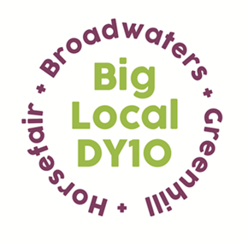
Partnership Meeting
Notes

13th May 2020,
Online Zoom Meeting
6:00pm – 7:00pm

- Present: Beth, Jayne, Brenda, Stuart, Laura, Adrian, Robert, Helen
Apologies: Sarah, Matthew, Vander

- Notes from April’s meeting: read and approved

- Conflicts of interest: none

- LTO – St George’s finance update – Partners were asked to look at the spend report that had been circulated. Robert informed Partners that £40,500 should be released to us this Friday. He will have to submit another spend report in 3 months’ time for additional funds to be released.

- Covid-19 Support update:

a) Online Forum – The weekly meetings are working well. Wyre Forest and Hagley Project and St George’s Church have recently joined the forum. Home-Start are looking at running a pop-up clothes shop at Kidderminster Youth House when lockdown is lifted and St Georges are supporting their elderly volunteers via check in phone calls and Zoom video meetings. Franche Food bank are rebranding to Wyre Forest Food Bank, so that they appeal to a wider range of people.

b) Activity Packs – The first three weeks of activity packs have been sent to print; they should arrive at the end of the week to be distributed on Monday. The packs will be distributed to St Ambrose, St Oswalds, St Marys, Home-Start, Wyre Forest and Hagley Project and Wyre Forest Food Bank.

- Grants – two emergency grant requests have been supported- funding an over locker for an individual to create PPE for local residents and a second grant to provide free cakes for care homes in the DY10 HBG area.

- Escape Room request – An application has been submitted by Kidderminster Escape Room, asking for assistance to pay four months’ rent on their premises.

The Partnership agreed that paying for an organisations rent does not fit with the grant guidelines, however Adrian proposed that alternatively, the Partnership could support them in another way by contributing towards the costs of employing a local person from our area. The Escape Rooms would need to revise their application and provide evidence that the person who is employed is living in our area. This was proposed by Adrian and seconded by Laura.

- Legacy and website update – Stuart is putting together the paperwork for the legacy and is still struggling to get a response from Companies House. He explained that Luke has been creating a new layout for the website. Beth shared the proofs with Partners. The Partners were pleased with the work on the new website so far and agreed that it looked fresh and engaging.

- A.O.B

Brenda asked the Partners if there was anything else that they thought we should be supporting at this current time. Adrian voiced a concern around unemployment, especially youths who are just leaving school and the impact that this will have on their mental health.

It was suggested that we set up another forum, linking up local schools, colleges and employment and training schemes to see what we can do to tackle this issue and find out what mechanisms they already have in place for school leavers. Stuart will work on this and contact organisations.

The Partnership agreed to meet again two weeks from now. The next meeting will be Wednesday 27th May at 6pm.

