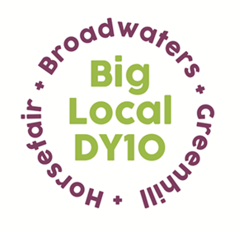
Partnership Meeting
Notes

1st April 2020,
Online Zoom Meeting
7:00pm – 8:15pm

- Present: Beth, Jayne, Brenda, Laura, Helen, Matthew, Robert, Stuart, Adrian, Vander
Apologies: none

- CAB Wyre Forest Proposal – Beth gave an overview of a proposal that Citizen’s Advice had submitted, asking for £2,000 to fund their online directory for another three years. The Partners agreed that it was a crucial tool for people, particularly in the current situation, although needs to be promoted more to make people aware of it. Beth will promote the tool via our social media channels. Beth to ask Citizens Advice if we could support them in any other ways. This was proposed by Matthew and seconded by Jayne.

- COVID – 19 Update - Beth and Stuart have been supporting Franche Food bank, helping them to deliver food parcels twice a week. Beth has updated the Big Local website with a new section to support the community during and following the pandemic. Brenda suggested that we look at posting recipes that you can create from food you have in your store cupboard, using some examples from the ‘Beyond the Foodbank’ book. Partners were asked to send any recipes they had to Beth. Helen suggested we find out if a local organisation or individual will create video demonstrations of the simple recipes. Beth will put out a request to see if anyone would be willing to create these.

Beth and Stuart have been working on setting up an online forum to connect local organisations. They have a core group of people who will be joining them on a Zoom meeting next Wednesday. Once they have an initial meeting, they will then branch out to other organisations. Jayne suggested getting in touch with organisations that we have worked with previously from the health and wellbeing forum and summer activities. Jayne to send contacts over to Beth and Stuart.

- Revised Plan - Jayne shared her screen with the Partners and circulated the revised plan that she had been working on with Brenda. Each page that had been amended was looked through and Partners made comments. It was agreed that everyone was happy for it to be submitted. Jayne is to send an invoice for the additional hours she has worked. Brenda asked the Partners if Jayne could purchase her work laptop, the Partnership agreed a cost of five pound. Jayne is to take this off her total cost of hours when submitting her invoice. This was proposed by Vander and seconded by Adrian. Beth thanked Jayne and Brenda for their time spent revising the plan. Jayne will circulate a finalised version of the plan.

- A.O.B - Helen informed the Partners that Local Trust will be holding weekly Zoom sessions for Big Locals to share responses to the coronavirus. Beth will circulate the link to these meetings.
The next Partnership meeting will be Wednesday 15th April via Zoom at 7pm.

