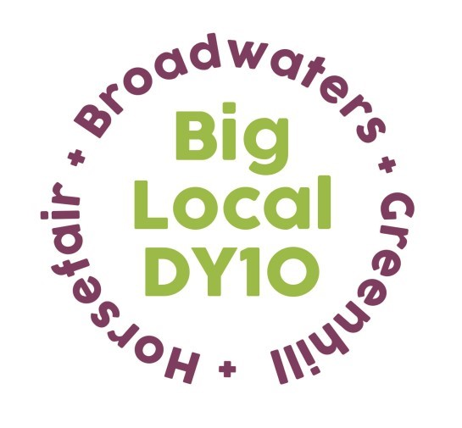
Grant Application for Organisations
Please ensure that you read the Guidance Notes before completing this form.

Should you have any queries please email us at grants@biglocaldy10.org
1. ORGANISATION CONTACT DETAILS
1.1 Organisation’s Name : Please ensure that this is the constituted name or if applying as a new partnership, that it is the constituted name of the lead organisation.
1.2 Contact Name and Address. This must be the person who is able to discuss the organisation and the project being applied for if required. Please provide the address of the lead organisation if this is a new partnership project.
1.3 Contact Details: Please ensure a landline telephone number is submitted if possible.
Phone
Mobile
Email
Please tick box to confirm that your organisation has been active in the last 12 months delivering activities or services within the Big Local DY10 area. If you are a newly formed Not-for-Proft organisation, please enter ‘NEW’

ABOUT YOUR ORGANISATION
2.1 What does your organisation currently do?

2.2 Do you have a bank account? Yes/No
This is the bank account that the grant will be paid into should you be successful.
Please provide your bank details. If you are successful in securing a grant you will be asked to submit a copy of an original bank statement.
Account Name | Sort Code | Account Number
2.3. Has your group received any grant funding in the past? If yes please provide details of the three most recent grants.
Funder | Amount Awarded | Date of Award | Project Name
2.4 Please detail the last project you delivered. This question is to find out about your track record and the ability of your organisation to manage projects. Please also detail your group’s experience of delivering any similar projects and what skills and abilities you have in your management committee.

ABOUT YOUR PROJECT
3.1 Project Title. Please give the name of your project, not your organisation’s name.
3.2 Is this for new work or to continue funding existing work?
New Existing

3.3 Project Summary. What activities will you undertake with the funding provided?

3.3 cont. Please also detail how you will advertise and market this project and when it will take place.

3.4 Please detail the need for this proposal in the area. What information have you gathered that demonstrates the need in the area .
3.5 How will the project meet these needs?
3.6 What outcomes do you hope to achieve? An outcome of a project is the change that will be achieved as a result of the activities carried out.

3.7 How will you measure these outcomes? How will you know if you have achieved these outcomes and what evidence will you collect to demonstrate this?
3.8 Where will your project or activities take place? Tell us at what venue or where in the area the activities will take place. If you are taking people out of the area then please explain why and what benefit it will be to the recipients .

BENEFICIARIES
4.1 How many people will benefit from your project?
4.2 How will you ensure your activity will be inclusive and accessible to all? What steps will you put in place to ensure it is inclusive? How will you promote it to benefit the maximum number of people in the diverse communities of the area?
4.3 What will be the age range of the beneficiaries?

PROJECT BUDGET
5.1 How much will your project cost? Grants to individual Not -for-Profit organisations can be up to £2,000. Amounts above this levels will be referred to full Partnership for consideration.
5.2 What will you spend this funding on? For more help on how to complete this section see the FAQs.
ITEM | AMOUNT
E.g. 1 sessional worker for 4 hours | £240.00
per week for 6 weeks at £10 per hour
5.3 Will you require any additional funding for this project? Yes No

5.4 If Yes, where are you looking to get the rest of your funding from and when do you expect an outcome?
Funder | Date Applied | Expected outcome date | Amount Requested

DECLARATION
When you fill in this section please print in BLOCK CAPITALS and include your full name.
The signature on the application form must be original, we cannot accept photocopies or faxed signatures.

The Declaration—Please ensure you read before signing.
- I have the power and authority to accept any awards offered, on the conditions shown, if we do not meet these conditions, the award will be repaid.
- I understand that any award offered may be publicised by Big Local DY10, and Local Trust.
- I confirm that the information we have given is true and we have answered all the questions on the form that are relevant.

I confirm that we will ensure any grant that is awarded will be spent within 12 months of the award date, and I will provide a report in the format of a Project Scrapbook (provided by DY10).
Contact Details on behalf of ______________________________ (Organisation’s name) Name
Signature

Position Date

CHECKLIST
Applying as a single Not for Profit Organisation
Completed and Signed Application Form Sections 1-6

