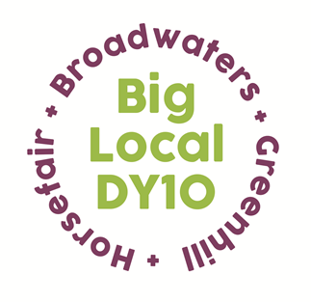
.
Partnership Meeting Notes

20th June, 2018,
St Ambrose’s Social Club,
7.00 pm to 8.30 pm
And
1. Present: Chris, Helen, Jo, Siri, Susie, Matthew, Brenda, Jayne, Sarah, Vander
Apologies: Steve, Bethany
2. Notes from May meeting were read and approved.
It was noted that we had had to hold an Extraordinary meeting to discuss a Grant Application from Horsefair & Proud which had arrived too late and the event was already booked. The Partnership wanted it noted that they would not do this again in the future. (see separate notes of that meeting)
3. Conflicts of interest on agenda items for this meeting. None declared
4. Recruitment of CDW update: After advertising the post, the interview date is 28th June at 1.00pm. There is only one applicant so far.
5. S.L.A. for L.T.O. It was agreed that we should develop a Finance Policy with instructions on How to Proceed and a Petty Cash System. This would be circulated for agreement when completed.
Chris reminded us that as items cannot be retrospectively funded under the Local Trust guidelines, we need to ask Vestia to continue in the role of LTO during the period of the Summer Activities – i.e.until the end of August. This expenditure, and the Grants quarter ending June 30th, were all payments already agreed under the current funding plan.
6. H.R. Update The transfer of employment of the CDW seems to have progressed smoothly to date, with the final transfer date of July 1st. Home Start have a reputation as a really good employer and Jayne is looking forward to working with Belinda Derby who will be her manager.
7. Ben Comm formation – Update A discussion took place regarding the need for guidance in the formation of the Ben Comm and it was proposed by Siri and seconded by Sarah that we should invite Kim and Louisa to quote for 5 days work to help us through this time. Chris to talk to them about this. Chris will also write the cheque for £900 for the Ben Comm registration and invoice us for this. Helen reminded Partners that she could have no part in the Ben Comm.
8. Summer Activities Jayne gave a brief overview of the progress of the Summer Activities and the recent Breakfast for supplier organisations. It was suggested that we should have a Partnership recruitment stand at the Big Picnic on August 30th
9. A.O.B.
Mr Tee in the Park. Sarah wanted it known that she was not happy with the Grant we had felt forced into agreeing to for the Mr Tee event, and also the fact that there was no mention of Big Local DY10’s sponsorship of the event in Press coverage. Chris said Local Trust were strengthening their rules for the inclusion of their logo and that of the lottery on all Big Local funded events and promotions.
Brenda suggested that one of the first jobs of the new employee should be to write a Press Release about all the good things Big Local DY10 HGB has done as we don’t get the recognition we deserve.
Grants Committee In view of the current transition to the new LTO we should not promote the next Grants Quarter.
Chair Brenda gave her 1 year notice of stepping down as the Chair. The Partners expressed their dismay and gratitude for the job she has been doing for the past 4 years.

Next Meeting 18th July 2018,

