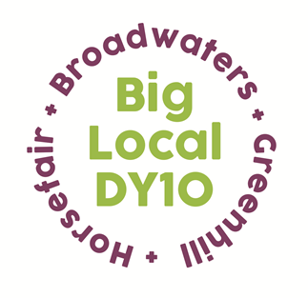
Partnership Meeting Notes

18th July 2018
St Ambrose’s Social Club,
7.00 pm to 9.30 pm

1. Present: Jayne, Siri, Brenda, Chris, Helen, Matthew, Susie, Colby, Bethany, Vander
Apologies: Adrian, Steve, Sarah
2. Notes from June meeting were read and approved.
3. Conflicts of interest on agenda items for this meeting. None declared
3a) Alteration to Quorate requirement. A discussion took place regarding the number of Partners required to be present for a meeting to be Quorate. It was proposed by Vander and seconded by Susie that the number should be reduced to Three. This was passed unanimously.
4. L.T.O. Update: Chris put together a draft service level agreement for the Partnership to look through. Setting up a money float was discussed as a potential new method, instead of using a credit card for financial needs. Jayne, Bethany, Brenda and Rob to put together a financial plan for Septembers Partnership meeting. Another meeting is to be planned, for the Partnership to meet our new L.T.O and to work out roles within each organization.
5. Ben Comm Update: The Partnership agreed that we should pay a Company Secretary, on the grounds that we need someone skilled with experience for the role. The hours that they will work are to be looked into further. Forms for Company Directors were circulated, Partners were asked to contact Jayne via email by 15th August if they feel they are suitable for the role. Jayne to send over the most recent form including specifics of the role and duties for Director.
6. Sladen View: The flat has been flooded. Oakleaf are to view the premises, to see if we can claim back on insurance for the carpet. Vestia are yet to fit goods for the flat that should have been completed in June. Jayne is to follow this up.
7. St Mary’s Grant: St Mary’s have applied for a new grant regarding a SEN unit. Partnership were unsure as to whether the unit is statutory and feel we have had a lack of communication from them regarding progress that they have made to their sensory garden that we funded last year. The grant is to be discussed further in the grants committee meeting (18/07) and Claire from St Mary’s is to attend our next Partnership meeting to answer any questions.
8. Summer Activities: Jayne gave a brief overview of the progress of Summer Activities. Banners are to be printed again this year to advertise the programme in DY10’s local areas. Partners agreed to help with flyer drops to promote the activities further.
9. GDPR: A discussion was had concerning the new GDPR laws and what this means for the Partnership. Chris has offered to share another Big Local’s document so that we have a template to work form. Jayne/Beth are also to look at Local Trust’s GDPR rules for further reference.
10. Big Local Representative Changes: Helen explained to us the changes that could be happening with Big Local representatives within the next year. There appears to be an area of uncertainty as to whether reps will have to take on an additional two more areas, to slimline the organization. Helen suggested that we could contribute to the Local Trust website and send feedback on this topic if we wish to do so.
11. Future Families Grant Application: The Partnership agreed that this was a fantastic idea and would like to make progress with it. Although have many questions regarding ensuring that the children are from DY10’s area and upping the age to 0-18. Jamie is to be invited to the next Partnership meeting in September to discuss.
12. Partnership Away Day: The Big Local connects weekend was brought up and on reflection, how this was a great partnership building exercise. This led to the discussion of a partnership away day, with the potential of a trip to 10 Downing Street accompanied by MP Mark Garnier. This is something to be considered.

Next Meeting: Wednesday 19th September 2018

