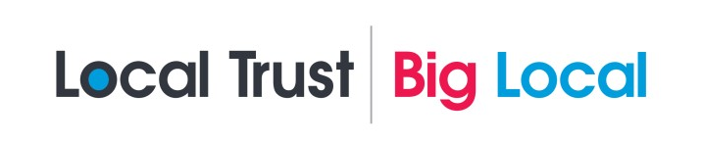
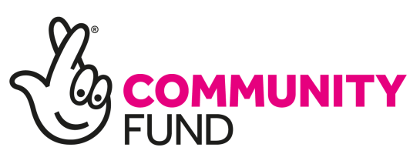
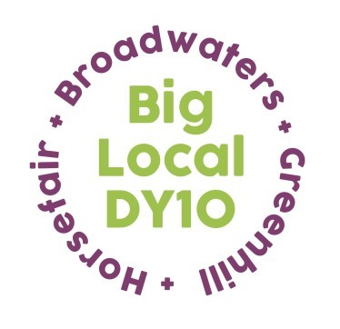
Grant Application for Individuals
Should you have any queries please email us at grants@biglocaldy10.org
Complete and submit this application form.

1 WHO ARE YOU?
Name: Please enter your full name:
 | Address: |  |  | Phone  Mobile  Email
If under 16, what is your date of birth?
If you are under 16 years you can apply for up to £100. If you are aged 16+ you can apply for up to £1,000.
 | 2. PROJECT NAME:
Where will your project take place? (Grants are for the benefit of residents of these areas ONLY)

 |  | Horsefair |  | Broadwaters |  | Greenhill
What do you want to do? Tell us about your project.

Why do you want to do this? How does your project benefit residents of the Big Local DY10 area?
What experience do you have that will help you deliver this Project?
How much will it cost?
ITEM | AMOUNT
TOTAL

Contact Details:
Checklist (official use only)
ID
Proof of Address
Bank A/C Details
Character Reference

Name

Signature

Date

